# University of Newcastle: Coding & STEAM 2019

# Week 3 Homework Tasks

In this document, we have included the Homework Tasks for Week 3 of the Coding in Stage 3 program. Please note that, in each week of the program there will be 2 hours of homework, which will count towards the total number of NESA accreditation hours (32) for completing in the program.

There are five main tasks that we would like you to complete before next week’s session. Further details about each of these tasks are given in the *Homework Tasks Detail* section. **We would prefer that you complete this activity while logged in your Student Account (the account name and password that I sent to you).** If you do complete the homework with your personal or Teacher Account, that is okay – but please let me know this in the email that you send me.

The homework tasks for Week 3 are:

1. Create a new project in Scratch and title it “Blue Circle, Red Square”
2. Use the Paint Editor to paint two new sprites: one that is a Blue Circle and another that is a Red Square. These sprites should start near the centre of the Stage, with the Blue Circle on the left and the Red Square on the right, as pictured in the image below:

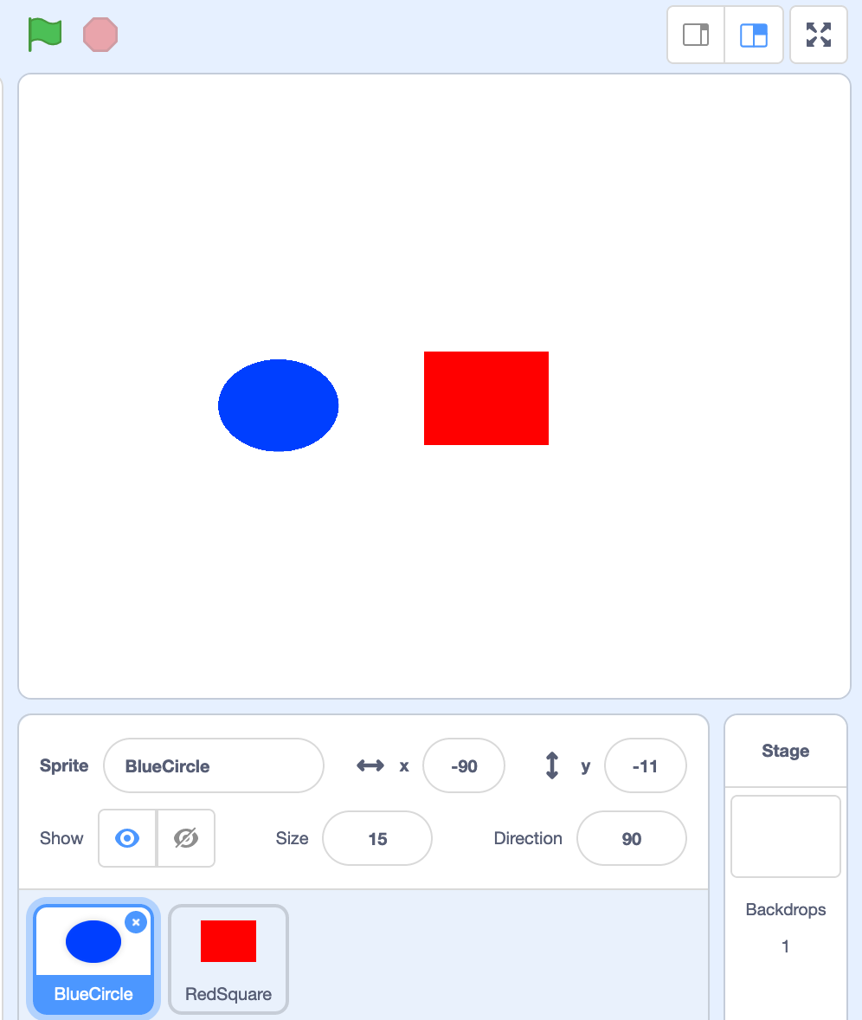

1. Add Code to “reset” the project when the Green Flag is clicked. When the project is “reset”, the two sprites should move back to their original positions near the centre of the Stage
2. Add Code to perform different actions. When the *space bar* is pressed, the Blue Circle should move upwards and the Red Square should move down, both at the same time. When the Blue Circle is clicked, the Blue Circle should move to the left. When the Red Square is clicked, the Red Square should move to the right.
3. Once you have completed the previous steps, share the project and add it to the “STEAM Week 3 Homework” *Class Studio*

An example project, which is similar to the above (but not exactly the same) can be viewed on the Scratch website from this link: <https://scratch.mit.edu/projects/184624482/>

Please email me at [Daniel.Hickmott@uon.edu.au](mailto:Daniel.Hickmott@uon.edu.au) with the subject line *“Coding & STEAM Week 3 Homework”* before the Week 4 session and let me know whether you have completed the tasks and/or have any questions about them. Once I have received this email and have checked that you have shared the completed project, I will record that you have completed the Week 3 Homework.

## Homework Tasks Detail

In this section, we explain each of the homework tasks in more detail.

1. **Create a Project Titled “Blue Circle, Red Square”**

Please note that you should be logged into a Scratch account (preferably the username that I sent you), when performing these tasks.

To create a new Project from within the Scratch editor (the screen that has all of the Sprites and blocks in it), you can go to the *File* menu and then click on the *New* button, as demonstrated in the image below:



Another way to create a Project, if you are on the Scratch homepage or on a Project page, is through the Create link at the top of the page. This link is highlighted in red in the image below:



Once you have a new Project open, you can change the title of this through the Editor or on the Project page. In the Editor, you can edit the text in the box at the top of the page to change the name of the Project. This text box is highlighted in red in the image below:



To complete this step, you should change the text in that box to “Blue Circle, Red Square” so that this becomes the Project’s title.

1. **Paint Two Sprites: Blue Circle and Red Square**

Scratch has a Paint Editor (similar to programs like Microsoft Paint and Adobe Photoshop) that you can use to draw your own Sprites.

To paint your own Sprite, you can click the button that is highlighted in red in the image below to open up the Paint Editor.



For the Blue Circle sprite, you should draw a small blue circle and move it into the centre of the paint editor, as shown in the image below. To draw a perfect circle, you can hold Shift while using the ellipse tool.



After creating the Blue Circle Sprite, you should paint another Sprite – one that is a Red Square. You can draw a perfect square by holding Shift while using the rectangle tool in the Paint Editor.

Once you have completed those steps, you should have two Sprites in your project, similar to those shown in the image below:



1. **Add Code to Reset the Project when Green Flag Clicked**

In this activity, the Blue Circle and Red Square Sprites will move to different places on the Stage. However, in this step, you should add Code to make these Sprites return to their original positions when the Green Flag is clicked. This will be a “reset”, which returns Sprites back to their starting positions, as you learned about in the Week 3 session.

There are different ways to move the Sprites back to their original position, but we recommend using the *goto* block. An example of Code blocks that will move a Sprite to the centre of the Stage - the coordinates (0,0) – after the Green Flag is clicked is shown below:

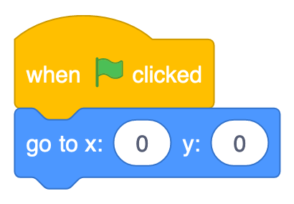

You could add similar blocks, to both Sprites, to make the Blue Circle and Red Square move back to their original positions. However, you would have to change the two 0s in the *goto* block to match the x and y co-ordinates of the Sprites’ starting positions.

You can test that your Code to “reset” the project works by dragging the two Sprites around the canvas with your mouse. When you click the Green Flag, do the Sprites return to their original positions on the Stage? If they do, you have done the “reset” correctly.

1. **Add Code that Responds to the Space Bar and Clicking on Sprites**

After adding the Code that responds to the Green Flag being pressed and moves the Sprites back to their starting positions, you should add some more *Events* to the Project.

There are three different *Events* you should add Code for:

1. When the *Space Bar* is pressed, the Blue Circle should move upwards and the Red Square should move downwards, both at the same time (in parallel). An example of how to make a Sprite move downwards after the *Space Bar* is pressed is shown below
2. When the *Blue Circle* Sprite is clicked, it should move to the left of the Stage
3. When the *Red Square* Spriteis clicked, it should move to the right of the Stage

There are a few different ways to make Sprites move across the Stage and you are welcome to use the approach of your own choosing. You can also choose how many times the Sprite should move and how quickly it does this movement. An example of Code in Scratch that will move a Sprite downwards four times after the *Space Bar* is pressed is shown below:

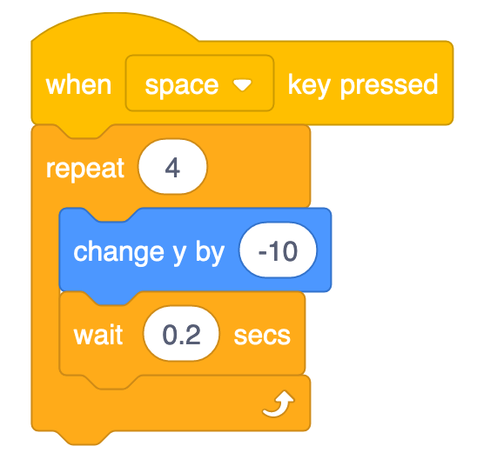

Once you have added Code to respond to the three different *Events*, you are ready to share the Project and add it to the Homework Class Studio.

1. **Share the Project and Add it to the Homework Studio**

Once you have completed the previous step, you should share the project and add it to the “STEAM 2019 Week 3 Homework” *Class Studio*. The key steps to complete this task are 1) to share the Project, and 2) add the project to the Studio.

To share the project, you can click the *Share* button when you are within the Editor view (the view that has all of the Sprites and blocks). The *Share* button, which is at the top and in the centre of the editor view, is highlighted by the red rectangle in the image below:



After clicking on the *Share* button, you will be taken to the Project page, where you can add your project to the studio. To do this, click on the *Add to Studio* button and then click the plus icon next to the *STEAM 2019 Week 3 Homework* Studio, as highlighted by the blue rectangle, as shown in the image below:



Once you have clicked on the plus icon, you will notice that the label with the Studio name goes green and a tick appears next to it. Click the “Okay” button and the project should now be in the studio. You can check that the project has been added correctly by going back to the “STEAM 2019 Week 3 Homework” Studio and checking that it is in there. If you cannot see the “STEAM 2019 Week 3 Homework” Studio, this could be because you are logged into your personal or Teacher Account. If you are logged into your personal or Teacher Account, you can skip this step and let me know this in the email you send me about the homework. After you have completed this last task, please email me and let me know, so that I can record that you finished it.